Task A (Scalar Subquery): Find the book with the maximum price in the library.
Give me the product whose price is the highest in the entire product table.

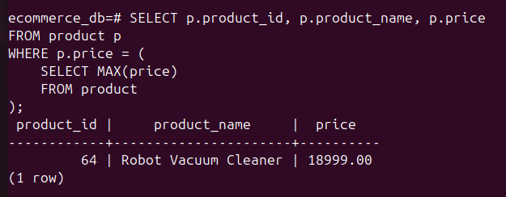

Task B (IN Clause): Select all members who have borrowed a book from the 'Mystery' genre (using a subquery to find Mystery BookIDs).

Give me all users who have ordered at least one product whose name contains ‘Running’.

